

Dear Teacher, Thank you for changing my life
26th November 2010



A love of the English language: Sister Mary gave Jonathan Aitken his earliest reading lessons
Jonathan Aitken, 68, is an author and campaigner for prison reform. He is a former Cabinet Minister, Member of Parliament, and ex-prisoner. He grew up in Ireland where he spent three years in a TB hospital in Dublin.
Dear Sister Mary,
Thank you for teaching me to love the English language. Thank you for giving me my earliest reading lessons with such loving inspiration during the three years I spent under your care in an Irish TB hospital, aged five to seven.
I have been thinking about you a lot recently after I was taken back to Cappagh hospital near Dublin by the BBC to make a Radio 4 programme, The house I Grew Up In. as soon as I entered my old TB ward, a cascade of vivid and happy recollections about your lessons tumbled from the attic of my memory.
Like most of the children you nursed, I was strapped down on a frame. Immobilisation combined with fresh air was the only cure for TB in the preantibiotic 1940s. So instead of using books, you taught me to read by projecting slides on a screen above my head using a magic lantern.
You were clumsy with this contraption. When its steel plates overheated (as they usually did) you would hop around and cry 'Drat it!' or even 'Damn!' a nun saying naughty words made me laugh. You laughed too.
Do you remember how you would put up a slide picturing the wind and then teach me all the other words for it like breeze, blow, gale, storm, tempest, typhoon or hurricane?
As you imitated these different types of wind by blowing out your cheeks and flapping your nun's habit you captured my imagination. As a writer some 60 years on, I still enjoy searching for synonyms.
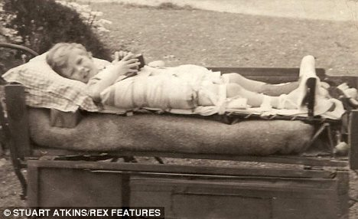
Jonathan in the Irish TB hospital as as a child: Immobilisation combined with fresh air was the only cure for TB in the preantibiotic 1940s
Not all the children in that ward survived. I was lucky to make a full recovery. Perhaps that was because you fired up my will to live by communicating your own enthusiasm for learning with such joie de vivre.
You also communicated the importance of having a spiritual dimension in life. not by preaching, but by example.
I well remember how you used to kneel beside my hospital bed saying your prayers until I dropped off to sleep. now, I have come to believe that prayer is very important. So thank you for that lesson too.
With great love and gratitude from your old pupil and patient.
Jonathan

